Equipment Needed to Set Up a Camping Dishwashing Station

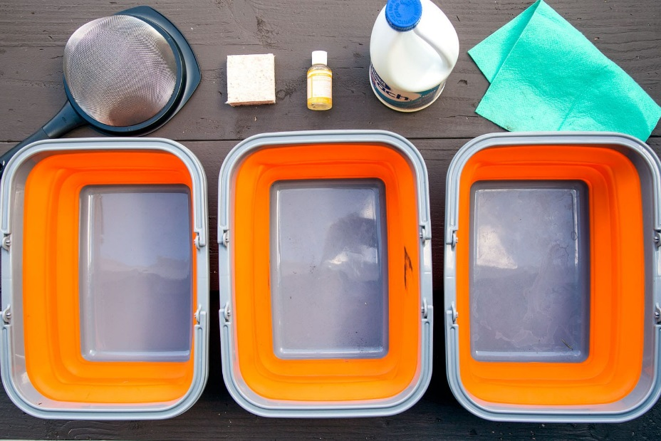
(3) Sinks – These can be collapsible camping sinks like the ones shown above, nestling plastic bins, just regular mixing buckets. Doesn’t matter what they are so long as they hold water and can fit your dishes inside.
Sponge/Brush – Either one will work, but you’ll need something to scrub off any caked on food that sticks to your plate. For cast iron, we use a special swatch of chainmail.
Biodegradable Soap – Standard dish detergent can be really hard on the environment, so you will want to pick up some biodegradable soap instead. Biodegradable soap needs bacteria in the soil in order to properly break down. So keep it at least 200 feet away from any natural water source, otherwise, it will be just as damaging as detergent.
Sanitizer – You can use a capful of bleach or a sanitizer such as Steramine. Bleach is more widely available and likely already sitting in your cupboard, but Steramine is more effective against viruses and claims to be gentler on the skin.
Metal Strainer – You’ll need a strainer to remove solid food wash from your gray water.
Chamois Cloth – Some super absorbent cloth to accelerate the drying process.

How to Wash Dishes While Camping

(Step-by-Step)

1. Clean Plate Club-Making the right amount of food and finishing everything on your plate makes washing dishes a lot easier. Be sure to get an accurate assessment of everyone’s hunger level before the meal so you can figure out exactly how much to cook.

2. Prep Dishes-When you are finished with your meal, remove as much food from your dishes as possible. The more food (and sauce) you can scrape into the garbage, the easier it will be to clean the dishes. Use utensils or a single sheet of paper towel to clean your plate as much as possible before putting it the queue to get washed.

3. The Three Bucket System-This process gets your dishes and cookware as clean as possible while using the least amount of water. We use collapsible buckets, but you could also use cheaper plastic bins too.
Also, we HIGHLY recommend washing with warm water, as it makes the entire process easier and vastly more enjoyable. We boil a pot of water and cut it with cold water to get something close to warm bathwater temperature.
Wash Sink – Fill this sink a ¼ of the way with warm water and a few drops of biodegradable soap such as Dr. Bronner’s or Campsuds. Start with the cleanest dishes first and then progress to the dirtiest dishes last. Once the item is entirely clean, shake off any excess suds back into the sink, and proceed to the next step.
Rise Sink – Fill this sink a ¼ of the way with warm water. When the dishes come out of the wash sink, they get dunked in the rinse sink water here. If the dishes aren’t quite clean or have excessive suds on them, send them back to the wash sink. After this rinse
Sanitize Sink – Fill this sink a ¼ of the way with warm water and your sanitizing agent (the amount will depend on how much water you use – the generally accepted ratio is 2 teaspoons bleach or 1 Sterimine tablet : 1 gallon water). Dishes coming out of the rinse sink should get a brief soak in this sanitizing bucket. While the soap cleans the dishes of food debris, the bleach water will ensure it is completely disinfected. This step is especially important if at any point your cookware, cutting boards, knives, etc came in contact with raw meat. But if you had a bowl of vegetarian chili for dinner, this final disinfection step might not be as critical.phase, the plates should be completely free of soap.

4. Towel Dry
When the dishes come out of the sanitizing bucket, towel them dry with a hyper-absorbent shammy before putting them away. It might be tempting to air dry plates, but we’ve found it just prolongs the whole procedure. Hand dry your plates and get back to enjoying the outdoors faster.

5. Search For More Dirty Dishes
When you are finished washing the last dish, double check to make sure it actually was the last dish. There’s nothing more annoying than finding out that somebody forgot to bring their plate over after you’ve already broken everything down and dumped your water. Make sure you’ve gotten all the cookware too. (We’ve often cleaned everything only to realize we forgot the pot we cooked everything in!)

6. Consolidate Graywater
Once you’re sure there are no more dishes, it’s time to consolidate your gray water. Dump the sanitize sink into the rinse sink. Then dump the rinse sink into the wash sink.

7. Strain out Food Scraps
Place a large metal strainer over one of the empty sinks and pour all the water through it. This will separate out all the tiny food particles that came off during the wash. Empty this solid waste from the strainer into your garbage.

8. Dispose of Graywater
Now you should be left with a sink with all of your gray water. If you’re at a campground with facilities with drain water basins (they will be marked), use them. If not, the best way to dispose of greywater is to broadcast (essentially spraying it) it over a large area. This should be done at least 200 feet away from any water source. Spreading the gray water out over a large surface area minimizes its impact on any one spot and allows it rapidly integrate with the soil.

